**Data Analysis (Annual Report)**

**MS Excel**

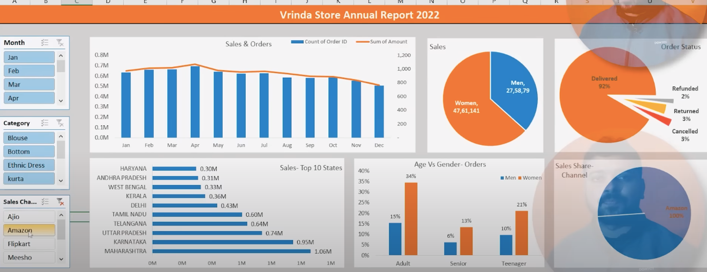

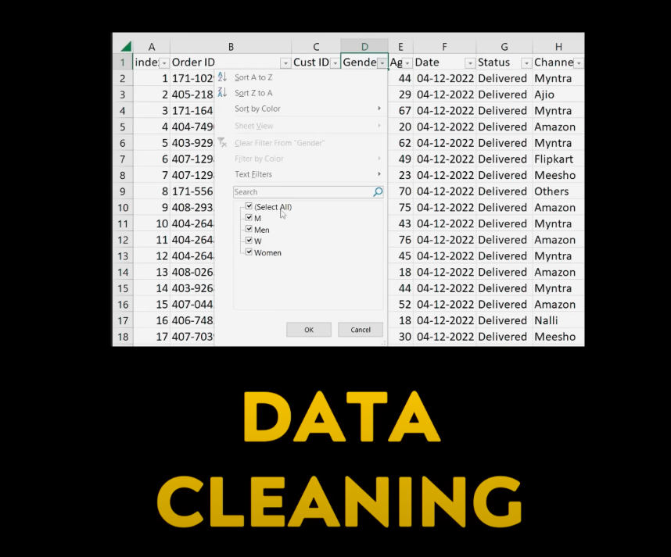

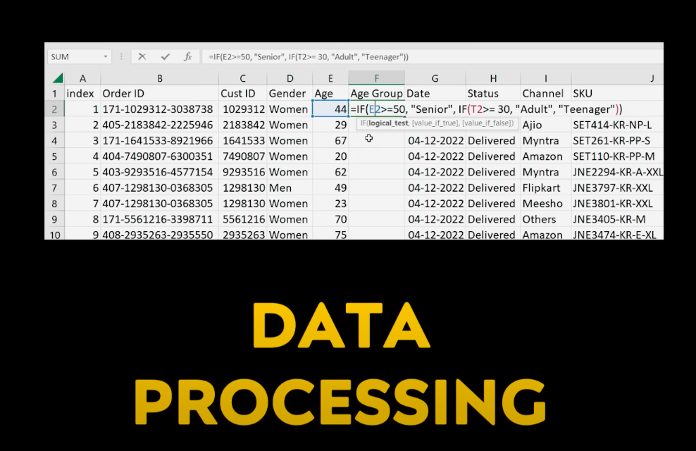

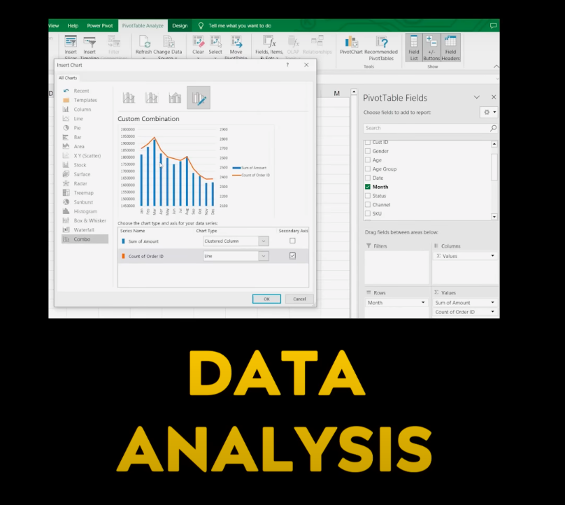

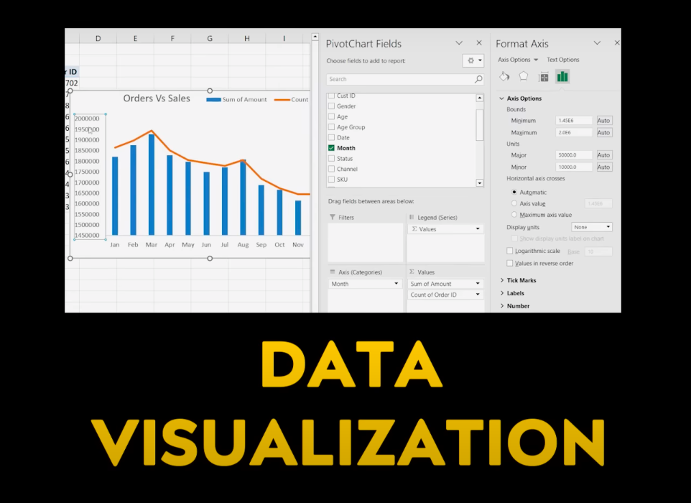

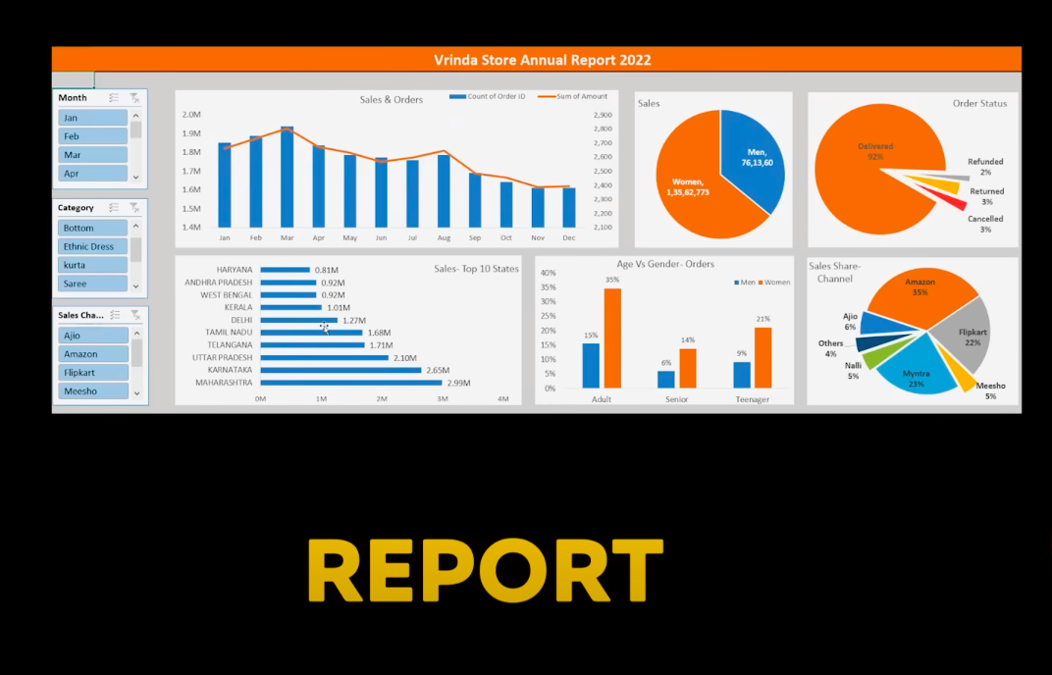

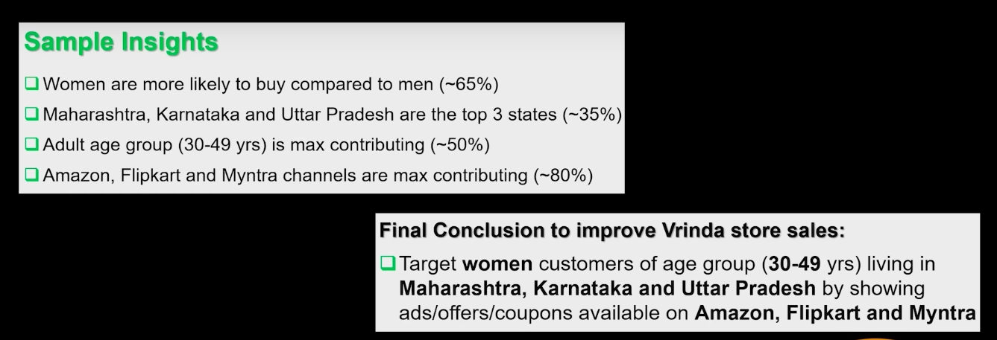



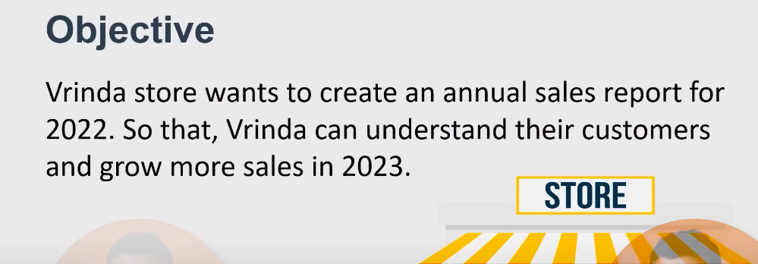

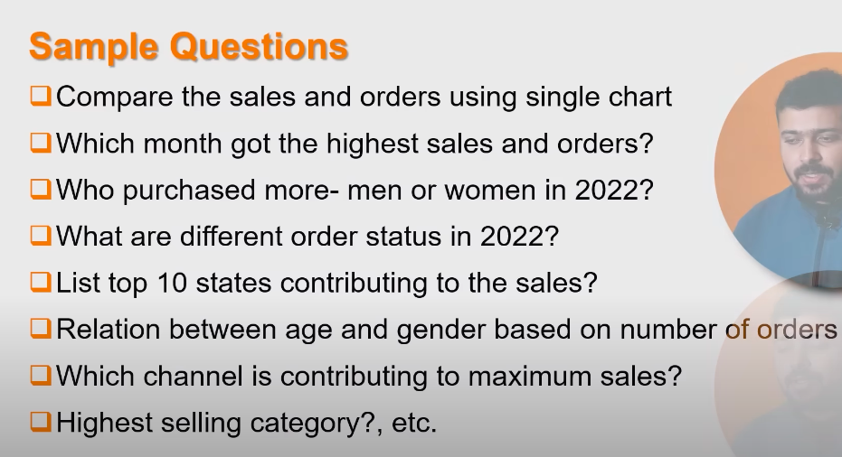

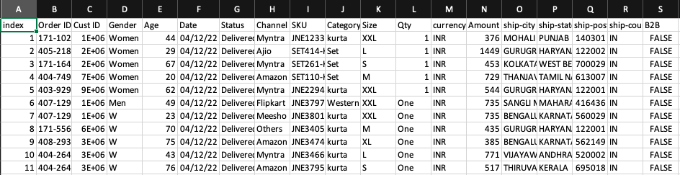



Here, we will go to every single column and verify the data.

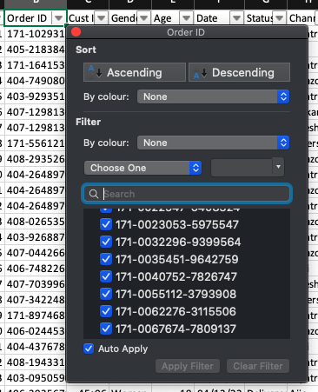

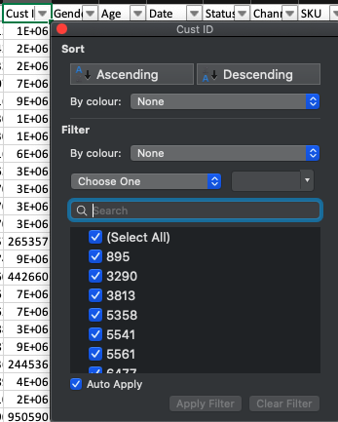

* **GENDER**

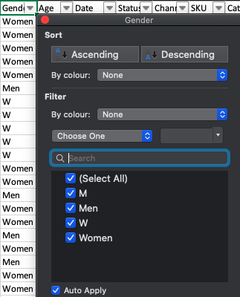

Filter out the **Gender** column as **M** only

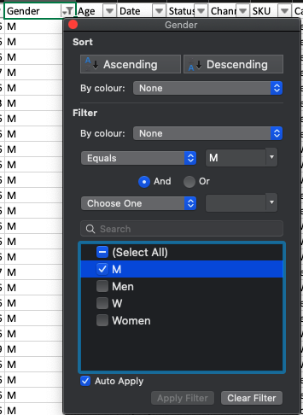

Select all data in Gender column by [cmd + shift + down arrow]

Then [ctrl + F]

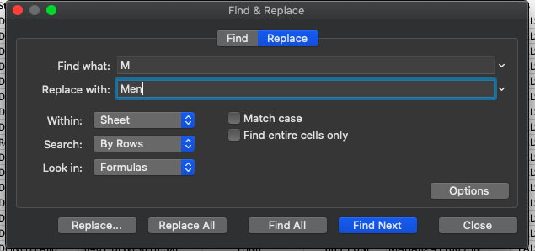

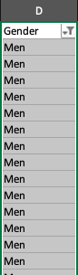

Do same for W -- > Women

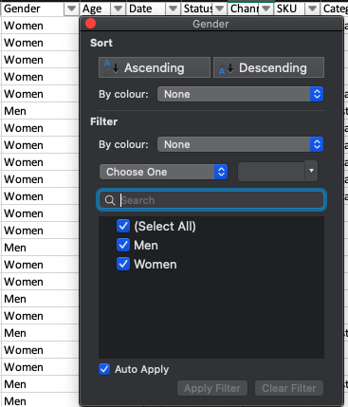

* **Quantity**

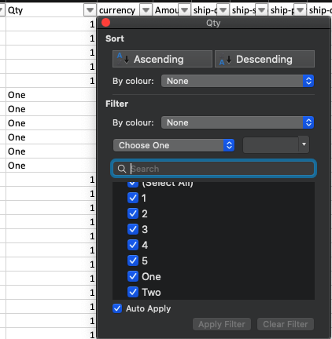

Select whole column, [ctrl + F], then replace One and Two.

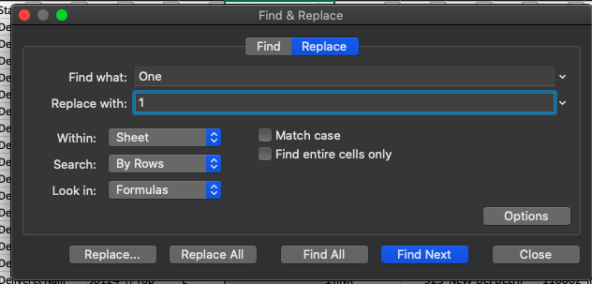

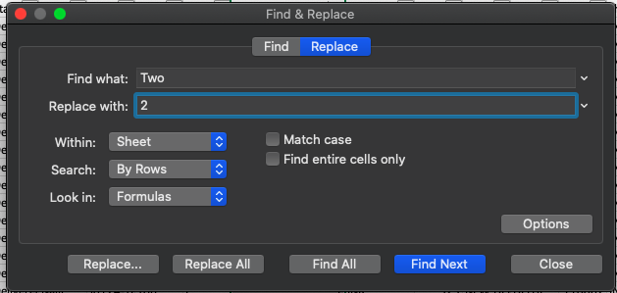

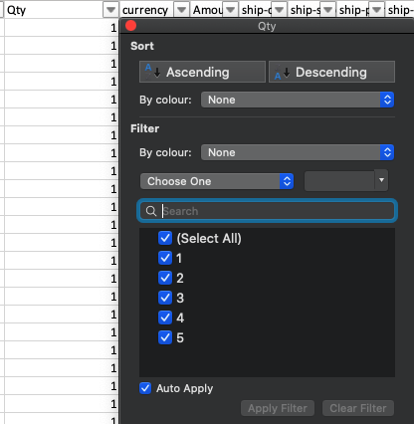



Here, we can do some calculations or process our data.

* We can make **AgeGroups** for **Age** column.

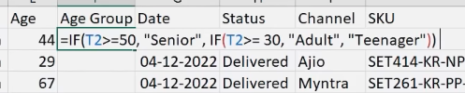

=IF(E2>=50, "Senior", IF(E2>=30, "Adult", "Teenager"))

Now, simply double click at the end of this cell, to copy this to all the other cells.

Note: If we will let this formula in all the cells, then it will make our system/ excel slow, so we can select all column values and do --> **Paste as values**

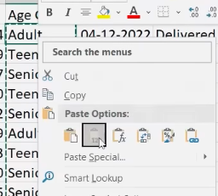

* One of the questions asking about Monthly data, so we can take months out from the **Data** column

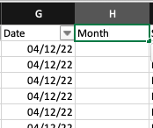

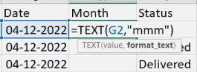

=TEXT(G2,”mmm”)

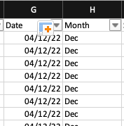



First, we have to make a **PIVOT TABLE** to see the possible connections between the attributes

Go to **Insert** --> **Pivot Table** --> **OK**

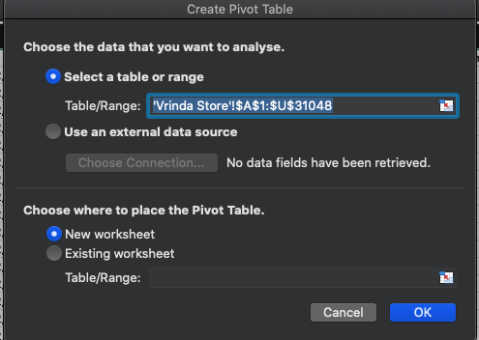

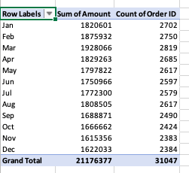

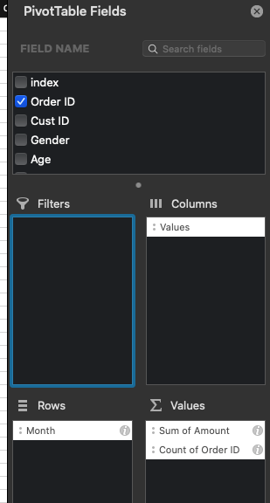

**Design** --> **Grand** **Totals** --> **Off for Rows & Columns**

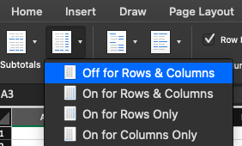

Now, select whole data table and select **Pivot Table Analysis**

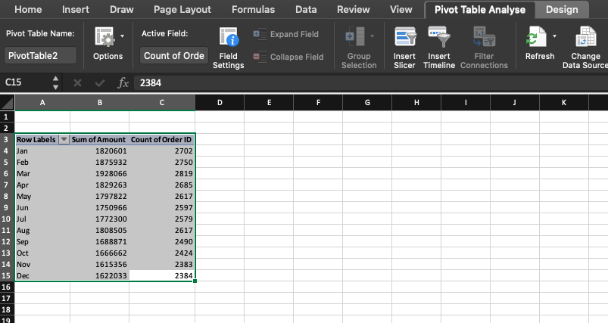

Click **Pivot Chart**

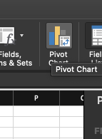

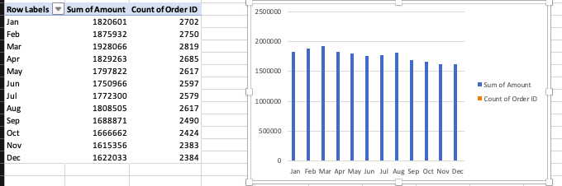

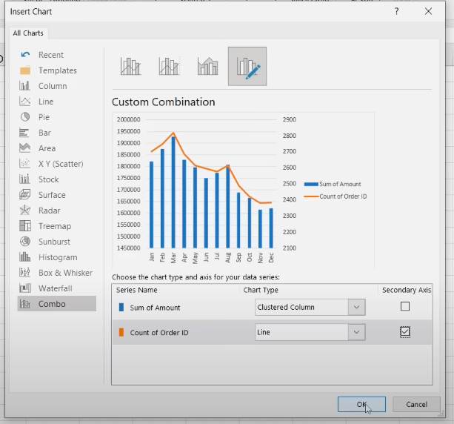

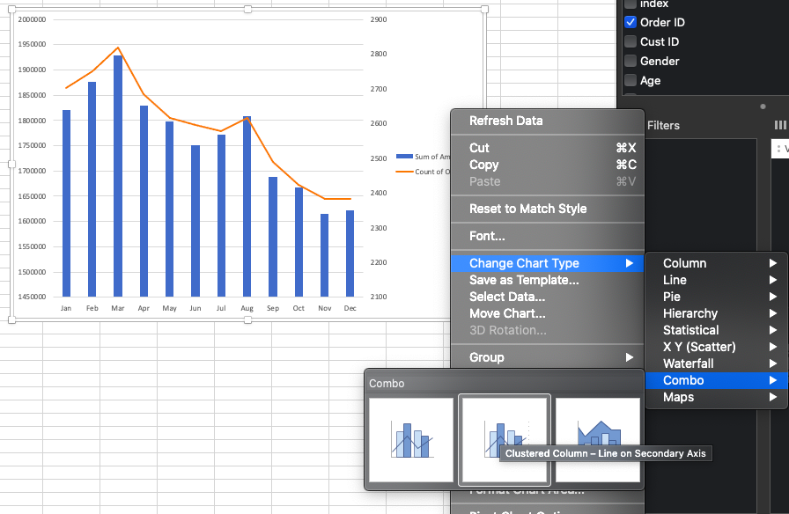

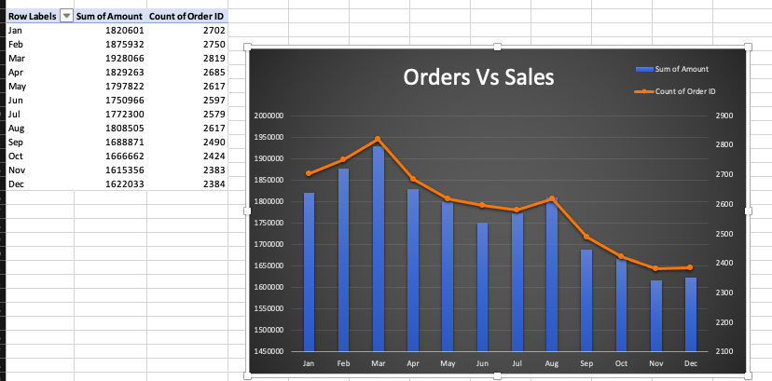

To show the Y axis values in readable million format

**Double click** on **Y axis** containing values, then fill up the **Format Code** --> **0.00,,”M”**

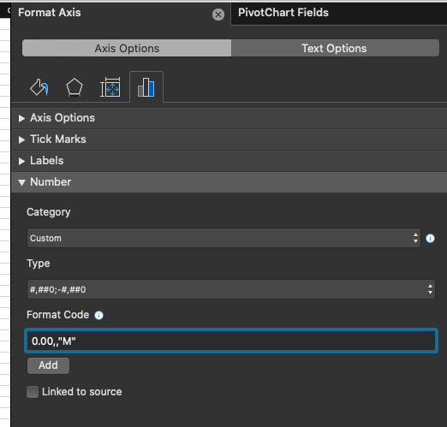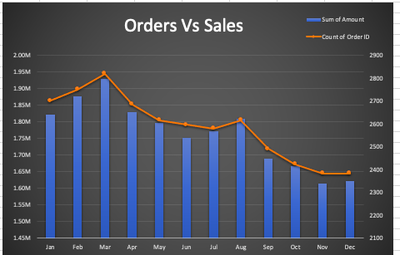

Now, create a new Tab/ Worksheet

View --> Gridlines (To remove gridlines from the back of sheet)

**Note**: If in future any of the data changes, then

Click **chart** --> **PivotChart** **Analyze** --> **Refresh**

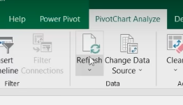

* Again, insert Pivot

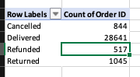

We can show the share percentage of these 4 row labels as follows:

**Insert** --> **Pivot** **Table** --> **PivotChart** --> **Pie Chart**

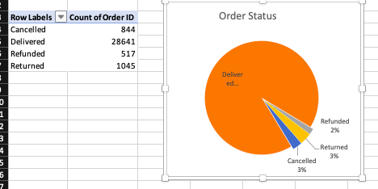

* Again, another Pivot Table

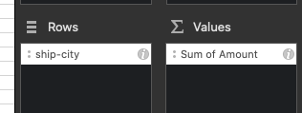

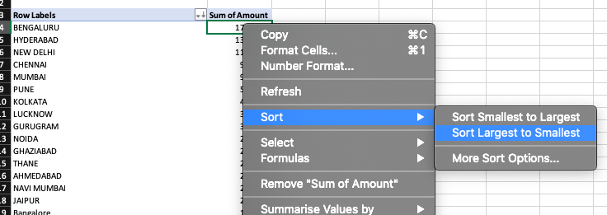

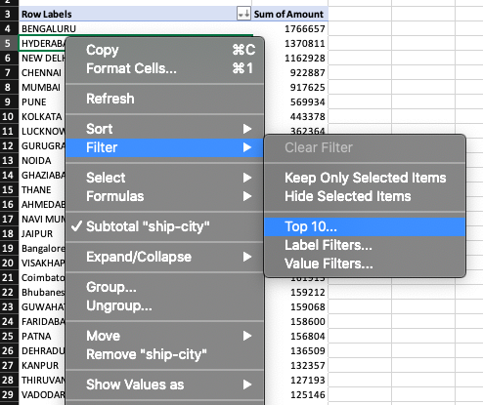

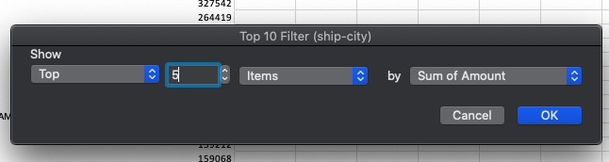

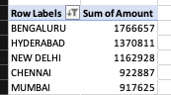

* Another Pivot Table

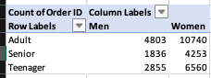

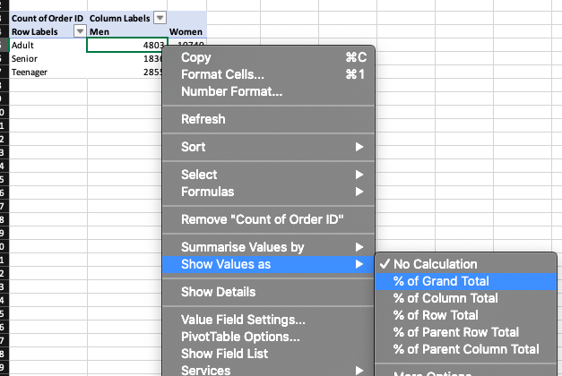

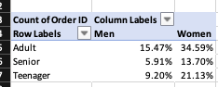

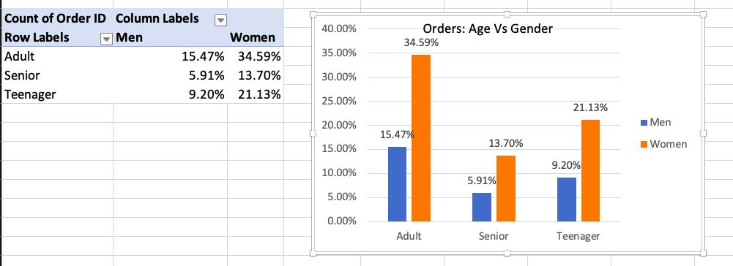

* One last Pivot

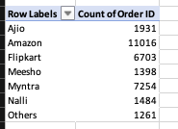

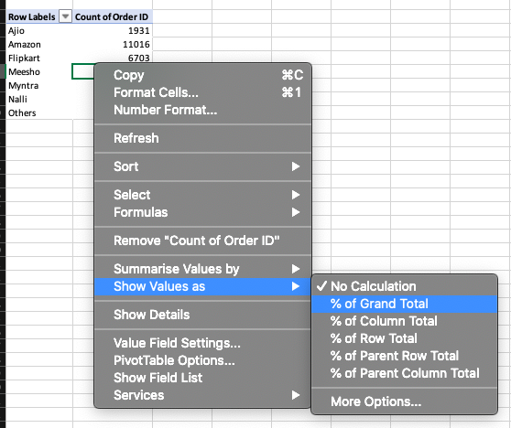

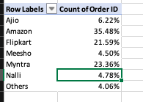

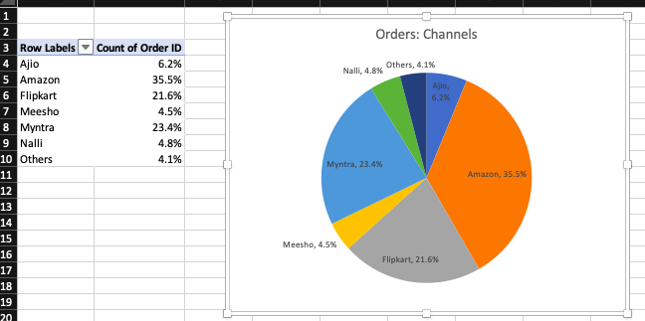

**Report**

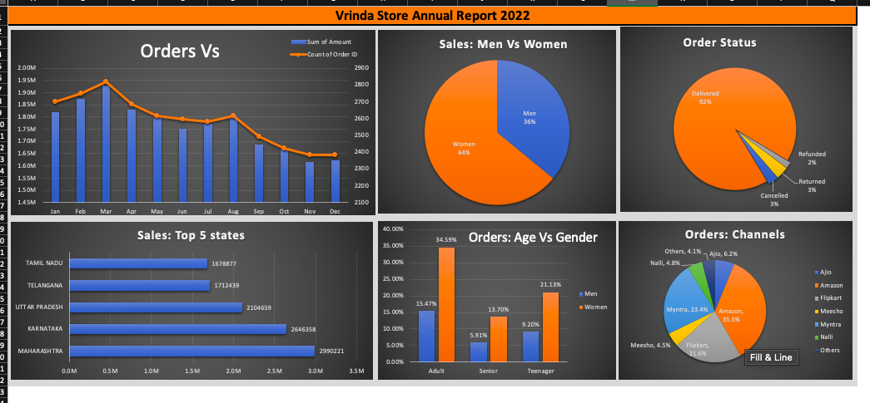

The report is ready

Now, we have to connect all these charts with the help of slicers.

**Click on any chart** --> **PivotChart Analyse** --> **Insert Slicer**

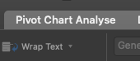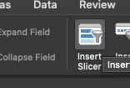

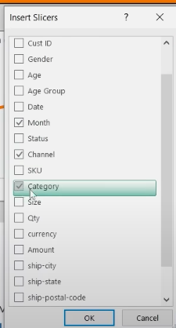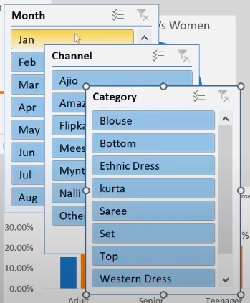

Now, right click on a chart and then select **Report Connections**

